Footballer’s wife Taneal Mead was the true Titan during childbirth
ANN WASON MOORE
GOLD COAST BULLETIN
OCTOBER 05, 2015 4:06PM
http://www.goldcoastbulletin.com.au/lifestyle/footballers-wife-taneal-mead-was-the-true-titan-during-childbirth/story-fnj94iqm-1227557843468

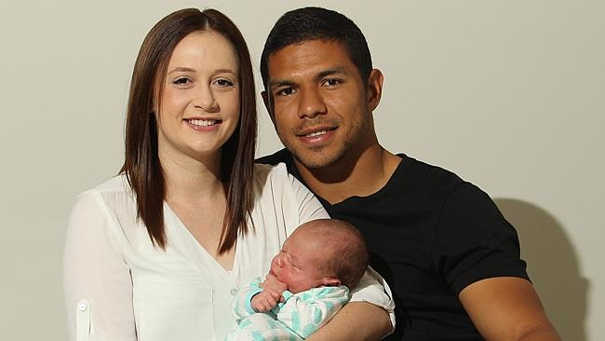
Gold Coast Titans player David Mead with his wife Taneal with their newborn son Paxton. Picture: Scott Fletcher

Her husband may be the professional footballer, but Taneal Mead is the true Titan when it comes to childbirth. The brand new mum says she conquered a brief but intense four hours of hardcore labour thanks to two secret skills — cheerleader husband David, who refused to be sidelined … and hypnobirthing.

Cradling bouncing baby boy Paxton in their Varsity Lakes home, Taneal says Gold Coast hypnobirthing expert Melissa Spilsted was the couple’s supercoach when it came to delivering the little family’s new team member.

“As soon as I heard about hypnobirthing from my sister-in-law, I knew it was for me,” says Taneal.

“David loved the idea of it because it uses so many of the principles that professional athletes use to overcome pain and succeed at their goals. He totally understood how it all worked so it made him the best birthing partner.”

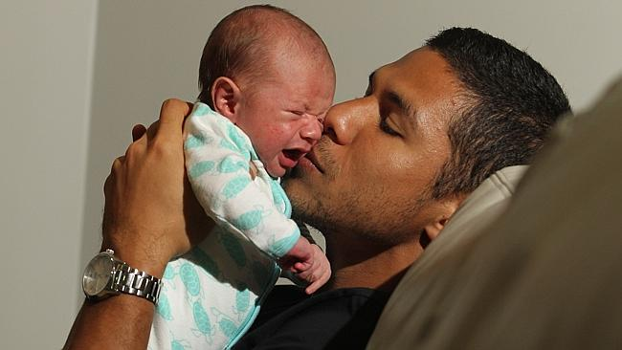

While it may sound strange, hypnobirthing is actually the latest labour trend. And with the likes of Catherine, the Duchess of Cambridge, a fan, it’s been making headlines around the world.

Hypnobirthing Australia director and Robina mum Melissa Spilsted says the antenatal education program uses deep relaxation, self-hypnosis, breathing techniques and education to help mothers feel more comfortable and remain calm through the birth.

“Hypnobirthing is really just a fancy word for a positive and mindful birth. It’s not about making you crow like a rooster while having a baby or waving a giant fob watch before your eyes,” says Melissa.

“We’re actually Australia’s fastest growing childbirth education group and we’re in the hospitals now. It’s really becoming mainstream because it’s such an easy, non-invasive way to make women feel comfortable about the labour process. It’s not just for women who want to do a natural birth either, the techniques can be used with drug intervention. I’ve also created a caesarean program, which is a world-first.

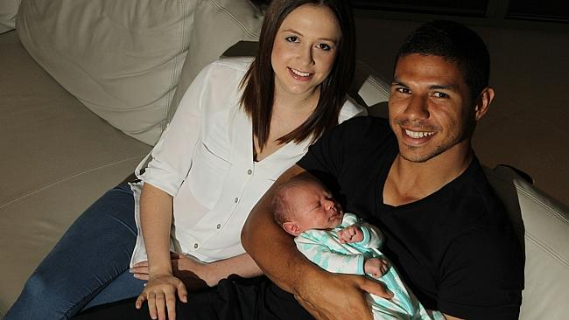
Gold Coast Titans player David Mead with his wife Taneal with their newborn son Paxton. Picture: Scott Fletcher

“It’s about giving women control so that they know what is going to happen in the birth, how their bodies will respond and techniques to calm the mind and the body.”

The course is not just for women, either. Partners can attend together, which Melissa says makes men feel more confident about the birth process. Taneal agrees David’s understanding of the technique made a massive difference during her birth experience at the Gold Coast University Hospital.

“David was amazing. He got the breathing, he got the self-hypnosis. When it came time to have the baby, he was just a huge support.

Because I knew exactly what would happen to my body I was never scared or worried, it was really intense but I just let it ride and David was there cheering me on,” Taneal says.

“I had a water birth and we used a private midwife so I really felt like I had a lot of choices in my labour, I really felt in control and it was exactly the experience I wanted. David was pretty proud of me. It was such a special time to share together. It was just us and the midwife.”

Melissa says her own husband first told her about hypnobirthing. She says childbirth was something she had always feared, particularly as she has a very low tolerance for pain.

“I skinned my knee one time while out at a restaurant in Burleigh and I nearly fainted. They had to call an ambulance. That’s how much of a wimp I am. So when my husband saw this story about hypnotherapy in the newspaper he told me and I thought I’d try anything,” she says.

“It was incredible. In the very first session with the hypnotherapist I just felt something ignite in me, the feeling that I can control my fear and my environment. I was a teacher at the time but later on I studied hypnotherapy.”

Melissa says while the self-hypnosis techniques grab attention, it’s more about tuning out distraction than leaving yourself open to persuasion.

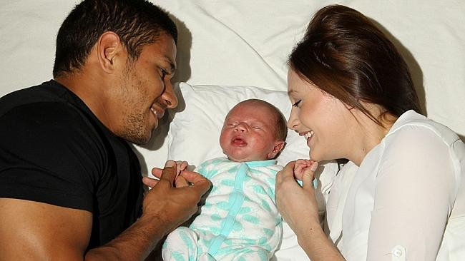
Gold Coast Titans player David Mead with his wife Taneal with their newborn son Paxton. Picture: Scott Fletcher

“It’s about learning to completely tune into your body,” she says. “When I was first learning my husband tried to help put me ‘under’ and suggested that after the baby I would have no issue with him going on long golfing weekends.

“Needless to say, that didn’t work out so well for him. You’re still totally conscious when you’re in that zone. It’s like when you’re daydreaming, you are in the world, you’re just focused on something in your mind. It’s a very useful technique, especially at a hospital. That environment just naturally puts us into a fearful mode because we associate it with sickness.

“We shut down and our bodies go into fight or flight mode, which means blood gets diverted away from non-essential organs — like the uterus. So it can really inhibit labour.”

With three children and three drug-free deliveries, Melissa says she’s a walking endorsement of the method. She’s also found numerous fans in sports stars, including David and Taneal, Olympic cyclist Sara Carrigan and gold medal swimmer Libby Trickett.

“Birth is like an endurance event. You wouldn’t just sign up for a marathon without training for it. It makes complete sense that parents are applying the same preparation to the birth of their child. Athletes especially are used to being in control, to having a plan, and this technique gives that to them,” she says.

“Mind you, it can be surprising to those who have never seen hypnotherapy in action. When I had my first child the midwife came in afterwards and asked if I was a Scientologist. She thought I was doing a silent birth like Katie Holmes. I explained it was just self-hypnosis and she thought that was fascinating. In fact, it was the doctors who told me I should write about it.

“The take away for my husband, of course, is that he is Tom Cruise.”

